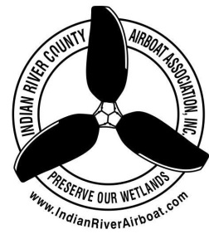
Indian River County Airboat Association, Inc.
Application for Membership
DATE:__________________________
APPLICANT:_____________________________________________________________
ADDRESS:_______________________________________________________________
CITY:________________________________ STATE:________ ZIP:_______________
HOME PHONE:________________________ CELL:_________________________
EMAIL:__________________________________________________________________
DOB ________/_________/___________ AGE: _________
APPLICANT SIGNATURE:_________________________________________________
Annual Membership is $25.00 per year and is due at the beginning of each year.
Members 65 years and older are considered lifetime members and will only be responsible for the first years dues of $ 25.00 and no fees for every year after.
Member(s) are encouraged to attend the monthly meetings, club functions and events.
IRCAA (Indian River County Airboat Association) responsibilities to their membership will be to supply the membership with a monthly meeting Minutes and communicate reminders via text or email of upcoming events and meetings.
IRCAA club meetings are held the Second Wednesday of each month unless there is a reschedule due to holidays and this will be announced via newsletter. The meetings are held in the banquet room at Marsh Landing Restaurant 44 N. Broadway St. Fellsmere, FL 32948.
Mail application to: IRCAA PO Box 650405 Vero Beach, FL 32965
Club website: www.indianriverairboat.com updated- 01/2021

